# FOCS Homework 15, for Day 15

You may edit your answers into this file, or add a separate file in the same directory.

If you add a separate file, please include the following at the top:

```

Student Name: Leon Lam [change to your name]

Check one:

[ ] I completed this assignment without assistance or external resources.

[X] I completed this assignment with assistance from ___

and/or using these external resources: https://www.cpp.edu/~ftang/courses/CS241/notes/self%20balance%20bst.htm

```

## I. Binary search tree ordering

Assume that the following tree structures are all properly constructed binary search trees, preserving the binary search property that any (internal) node's left child is smaller than the internal node and its right child is larger (or of equal value).

Anything labeled with a T can be assumed to be a (possibly empty) subtree (i.e., may contain zero or more nodes); anything labeled with a lower case letter is a single node.

What inequalities must hold in each of these trees?

### 0.

```

a

/ \

/ \

T1 T2

```

Ans: all elements of TI <= x <= all elements of T2

### 1.

```

b

/ \

/ \

c T3

/ \

/ \

T1 T2

```

Ans: T1<=c<=T2<=b<=T3

### 2.

```

d

/ \

/ \

T1 e

/ \

/ \

T2 T3

```

Ans: T1<=d<=T2<=e<=T3

### 3.

```

f

/ \

/ \

g T4

/ \

/ \

T1 h

/ \

/ \

T2 T3

```

Ans: T1<=g<=T2<=h<=T3<=f<=T4

## II. Extending this analogy: drawing trees.

### 4.

What other tree structures containing three internal nodes -- x, y, and z -- can exist? Draw these and describe the inequalities that exist among the internal nodes and their subtrees.

[Hint: There should be four more shapes.]

The relationship among x, y, and z doesn't matter. For convenience, we've arbitrarily labeled them top to bottom and the subtrees left to right.

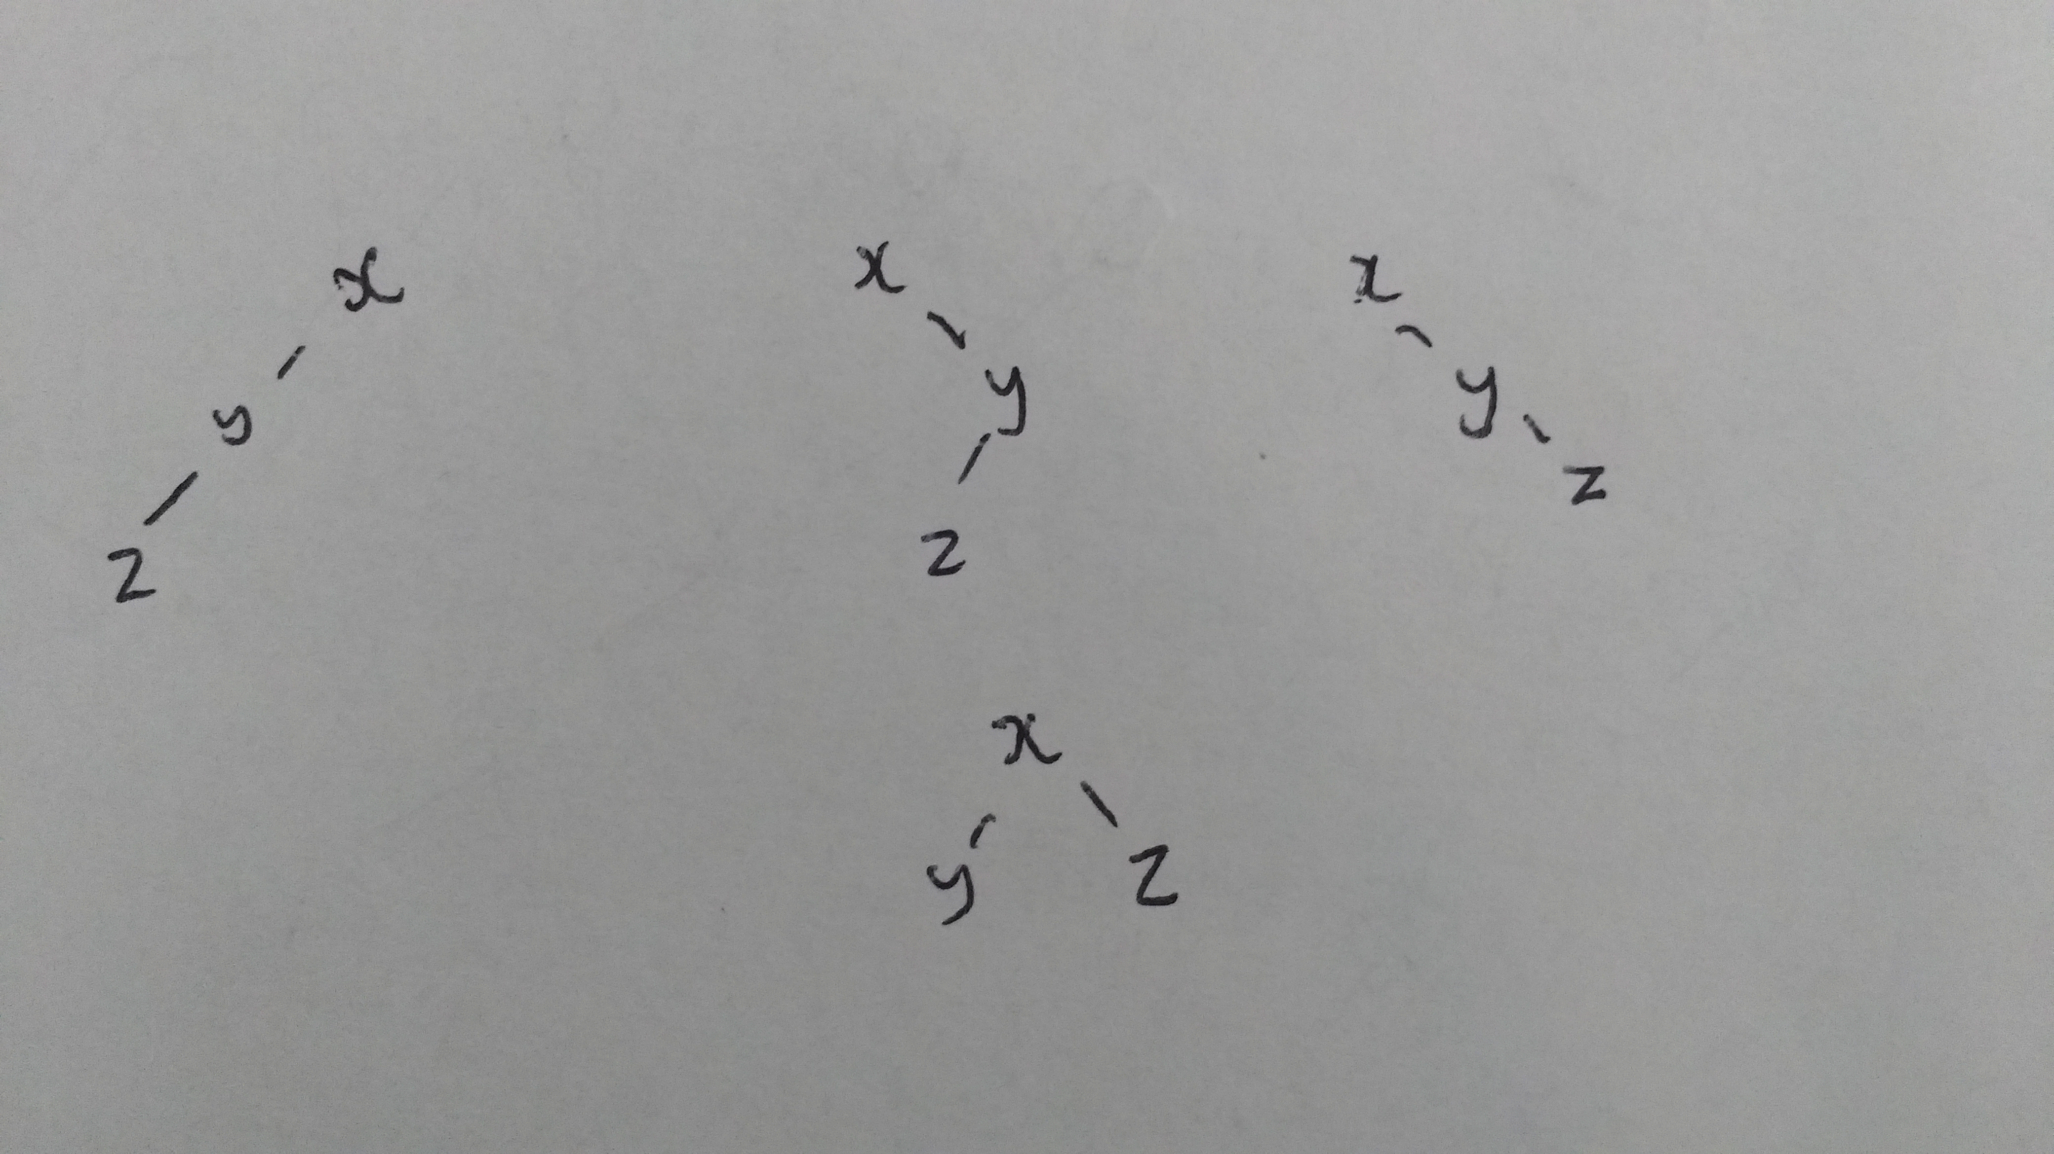

**I left out the (possibly empty) subtrees which would've been labeled with T. A binary search tree is recursively defined such that left child nodes are always smaller than the parent and right child nodes are larger than (or equal to) the parent. The 3 on the top row are unbalanced since one side has a greater depth than the other, while the one on the bottom row is balanced.**

## III. Observing balance

It is desirable for binary search trees to be balanced (or close). If we assume that each of the T structures has the same depth, the two-internal-node trees have the following property:

For EVERY internal node (x and y), the depth of the internal node's left subtree and the depth of the internal node's right subtree differ by at most 1. We call these trees almost-balanced.

### 5.

Does this property hold for any of the three-internal-node trees? Which ones? Which ones are NOT almost-balanced? (We call these unbalanced.)

**The 3 on the top row in qn 4 are unbalanced since one side has a greater depth than the other, while the one on the bottom row is balanced.**

## IV. Maintaining balance

Observe the following:

If you are given a binary tree of the form in question 1, you can transform them into the form in question 2 (and vice versa) while preserving the binary search property.

[Since they are both almost-balanced, this doesn't help, but it also doesn't hurt.]

### 6.

Use this insight to show how to modify each of the unbalanced tree forms with three internal nodes into an almost-balanced tree that preserves the binary search property.

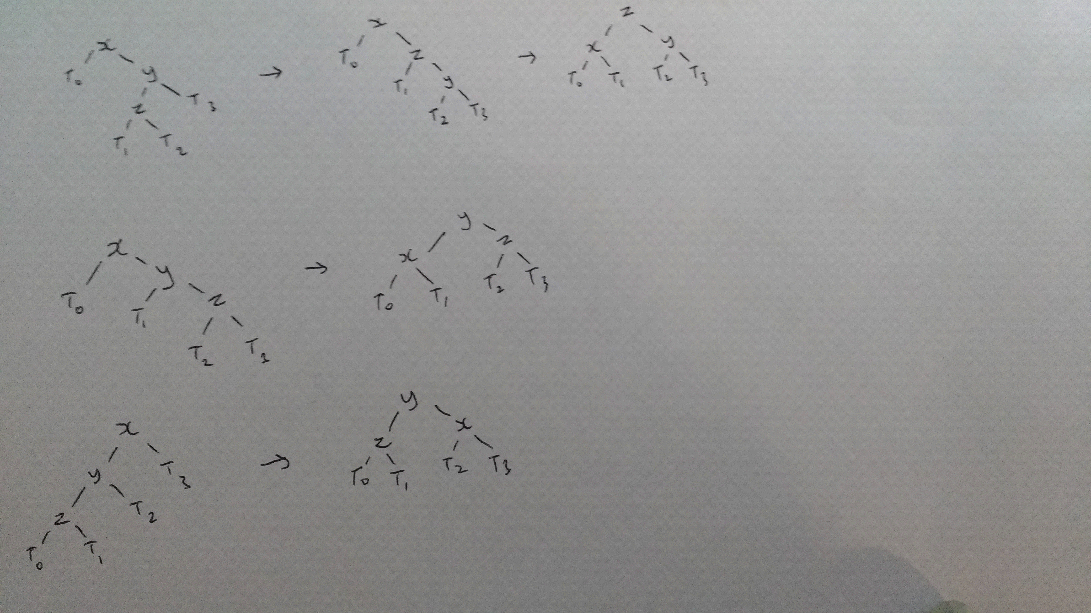

Sorry for the awful quality!

## V. Rebalancing

### 7.

Verify that the following tree is almost-balanced:

For EVERY internal node (x and y), the depth of the internal node's left subtree and the depth of the internal node's right subtree differ by at most 1.

```

8

/ \

/ \

6 14

/\ /\

/ \ / \

3 7 12 16

/\ / /\

/ \ / / \

2 5 10 15 20

/

/

18

```

**We look at internal node 6 and 20. Right subtree of 6 has depth 1, and left subtree of 6 has depth 2 (assuming leaves are depth 1). Right subtree of 20 has depth 0 and left subtree of 20 has depth 1. Same for the other nodes, but these two are the most likely to produce imbalance.**

### 8.

Insert the value 13 into this tree. Where does it go? Is the resulting tree almost-balanced? If not, see #11.

**13 is 12's right child. The resultant is almost-balanced.**

### 9.

Insert the value 17 into the tree. Where does it go? Is the resulting tree almost-balanced? If not, see #11.

**17 is 18's left child. The resultant is not almost-balanced.**

### 10.

Insert the value 4 into the tree. Where does it go? Is the resulting tree almost-balanced? If not, see #11.

**4 is 5's left child. The resultant is not almost-balanced.**

### 11.

Use the work you've done above to rebalance the tree. Start at the newly inserted value; work up until you find an internal node that has left and right children whose depth differs by more than one. Rebalance that subtree using the processes you created in #6. Continue to climb the tree, rebalancing any unbalanced (not almost-balanced) nodes as you go up.

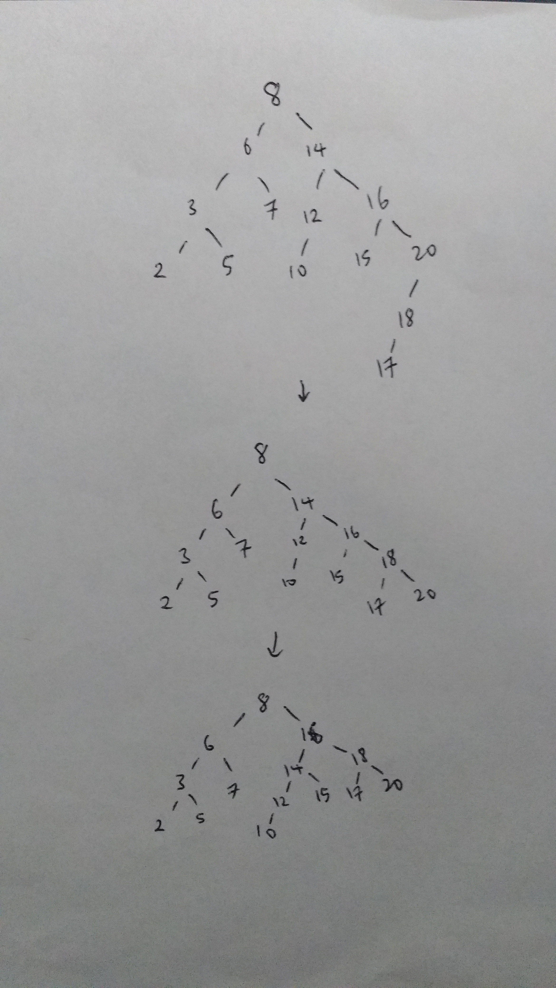

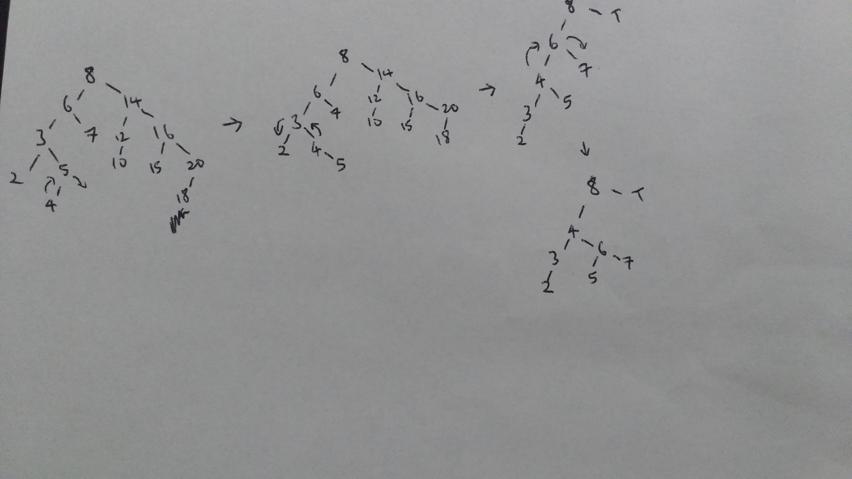

**Where T is the right subtree of node 8.**

### 12.

[Challenge] Assuming that a tree is almost-balanced when you make an insertion, and that that insertion may violate the almost-balanced property, can almost-balance always be restored solely by climbing the path from the newly inserted node to the root? Will you ever have to descend another branch? Why or why not?

**Almost-balance should be restorable without descending another branch.**

**If a tree is almost-balanced, that means the left and right subtrees of the tree root differ in depth by only 1. This means the most an insertion can do is increase the difference in depth to 2, which means a tree rotation on the root in the direction of the insertion will be able to reduce the depth difference back to 1 and restore the almost-balanced property.**